EXISTING PUPILS:

Consent form for processing pupils’ personal data

November 2020

Dear Parent
We sent forms out requesting permissions in August 2020 but do not appear to have received a reply from you. We would therefore like to ask you again and stress that, once we have your reply we will save these permissions for the rest of your child/ren’s time at St. Michael’s (although you may change them at any time if you wish by contacting school).
If you have already returned the form (overleaf), please accept our apologies but we would ask that you complete it again.
This will allow us to quickly check which children can / cannot be photographed for the website, by the local newspaper or for internal displays and so on, and so your help is really appreciated. If we do not receive a reply, we will record ‘no’ in each instance.
Please return this form by Tuesday 1 December 2020 – many thanks.

Yours sincerely
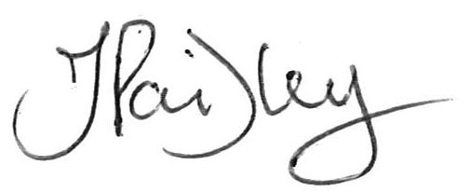

Mrs J Paisley
Headteacher

CHILD’S NAME: ……………………………………………………….
If more than one child, please name sibling/s below:
………………………………………………………………………………………………………………………………………
Photos and videos
We sometimes take photographs of pupils. We use these photos to help give people an idea of what life at our school is like, for example in our newsletters and on the school website.
As a school, if we use photographs of your child, we will NEVER publish their name next to them.
However, the local media – the ‘Cumberland News’ and ‘News and Star’ – sometimes ask for names so please indicate your specific preferences below.

Please tick the relevant box(es) below, sign and return this form to school.

Use of photos | Tick (√)
I am happy for the school to take photos of my child.
I am happy for photos of my child to be used on the school website.
I am happy for photos of my child to be used in the school newsletter.
I am happy for photos of my child to be used in printed school materials, for example, the school prospectus.
I am happy for photos of my child to be used in internal displays.
I am happy for photos of my child to be used on social media, for example Twitter.
I am happy for the school to take videos of my child.
I am happy for the school to use videos of my child for promotional purposes, such as on the school website.
I am happy for the local press to take photographs of my child.
I am happy for the local press to take photographs of my child and include his / her name.
I am happy for the local press to take photographs of my child but his / her name cannot be used.
I am NOT happy for the school to take or use photos or videos of my child.
I am NOT happy for the local press to take or use photos or videos of my child.

Signed : ________________________________

